Whitehills & District Community Council
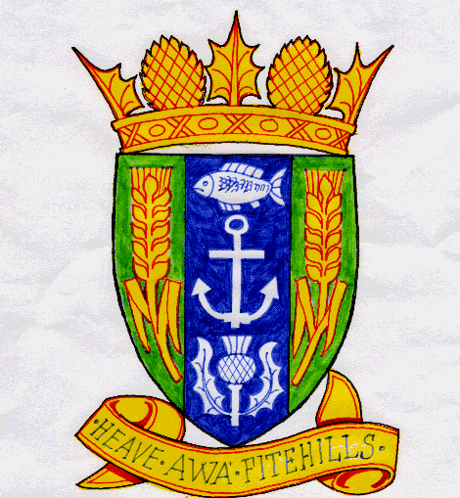

Boyndie Windfarm Community Fund

Annual income for this fund originates from Falck Renewables and results from the electricity generating capacity of Boyndie Windfarm. The money is to be administered by Whitehills & District Community Council and held in a bank account separate from that organisation’s other funds.

An open meeting will be held annually, or more frequently if the need arises, chaired by the Community Council Chairman, at which a ‘broad brush’ plan will be decided for spending or dispersing money over the coming year. A panel of two Community Councillors, elected annually by their peers, will carry out the detailed administration of the money, in accordance with this plan.

Departure from the annual plan would have to be agreed by majority vote at a full Community Council meeting. There is no reason why all the money received by the fund has to be spent that year. A decision to withhold some or all of the money in order to facilitate a larger project than can be financed from a single year of income, is acceptable. Approved applications should be drawn down within 12 months of date of approval.

As a general guide, it is envisaged that most of the funding will be spent on projects either wholly managed by, or closely involving the Community Council. It is acceptable, however, for a portion of the total income to be given out in the form of one-off grants to other organisations within the Community Council area. It is unlikely that such grants would be for general running costs of groups or organisations, nor would it replace their own fundraising efforts. Capital expenditure, or finance for specific projects would receive more favourable consideration.

Bids for funding must be made in proper format using the Application Form. There will be an expectation for all projects funded, whether run directly by the Community Council or not, to report back formally and regularly on the progress and success of the project.

Variations to these rules would have to be made by a majority decision at a full Community Council meeting.

A quick reference list of what the fund can and can not support is published overleaf.

Quick Guide

Can Support.

- Capital projects considered to be beneficial to the community defined by the borders of Whitehills & District Community Council. (see note)
- Revenue costs directly attributable to completion of such projects. (see note)
- Improvements to the environment of the community.
- Promotion or conservation of heritage and culture.
- Projects may address issues of education, recreation, social welfare, social inclusion, energy conservation or economic development.

The fund will give particular importance to furthering projects that benefit the community as a whole, rather than narrow bands of age or interest.

Can Not Support.

- Campaigns, events, or literature opposing windfarms or other forms of renewable energy production, or that would harm Falck’s business reputation.
- Ongoing ordinary running or maintenance costs of local groups or facilities.
- Furtherance of religious or political beliefs and causes.
- Benefit or financial gain of any individual.
- National or international charities and appeals, unless such an organisation plans a specific project to benefit directly the community of Whitehills & District.
- A service or facility that could reasonably be expected to be the responsibility of a statutory or commercial body.
- Projects or new facilities that will require ongoing running costs, unless it can be demonstrated that a sustainable source of revenue income is available.
- Projects or new facilities that duplicate or would render unsustainable, existing community groups or amenities.
- Applications made by incorrect means, such as by verbal canvassing of Community Council members, rather than by use of the Application Form

Note.
Examples of ‘Capital’ items:~ Buildings, equipment, furnishings, signs, picnic tables
Examples of ‘Revenue’ items:~ Staff costs, utility bills, maintenance materials, travel expenses.

